Advanced React and Redux 2018 Edition

2. Testing

1. Project Generation

Creating a project using “create-react-app”

2. Our First Test

With “create-react-app” we get all the testing setup so we don’t need to install any testing library.

Here we are testing the render content.

**App.test.js**

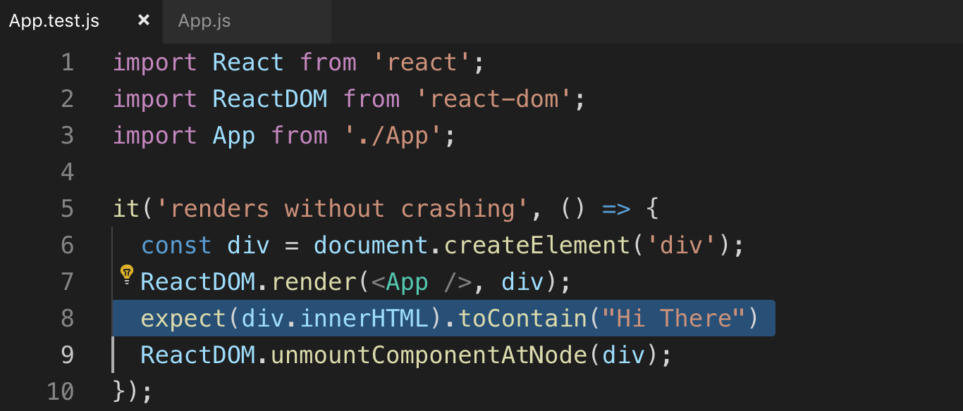

This test file make sure that the <App> component works the way we want.

toContain : to check the content

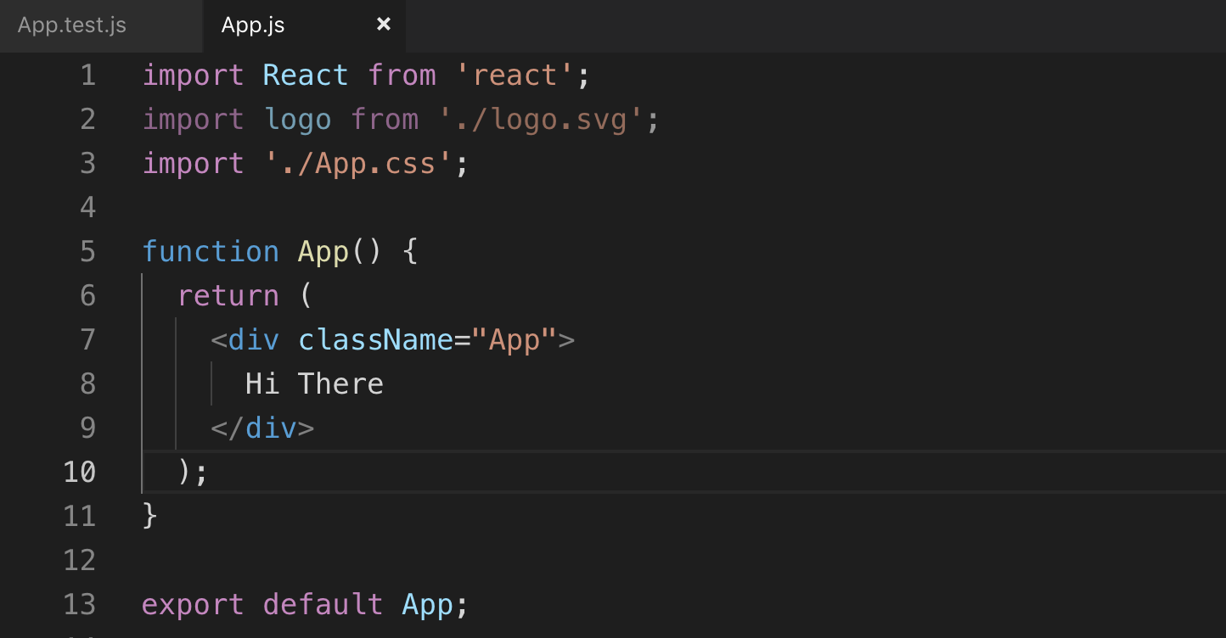

Command to run the test

npm run test

3. Introduction to Jest

When we run create-react-app we get all these dependencies automatically

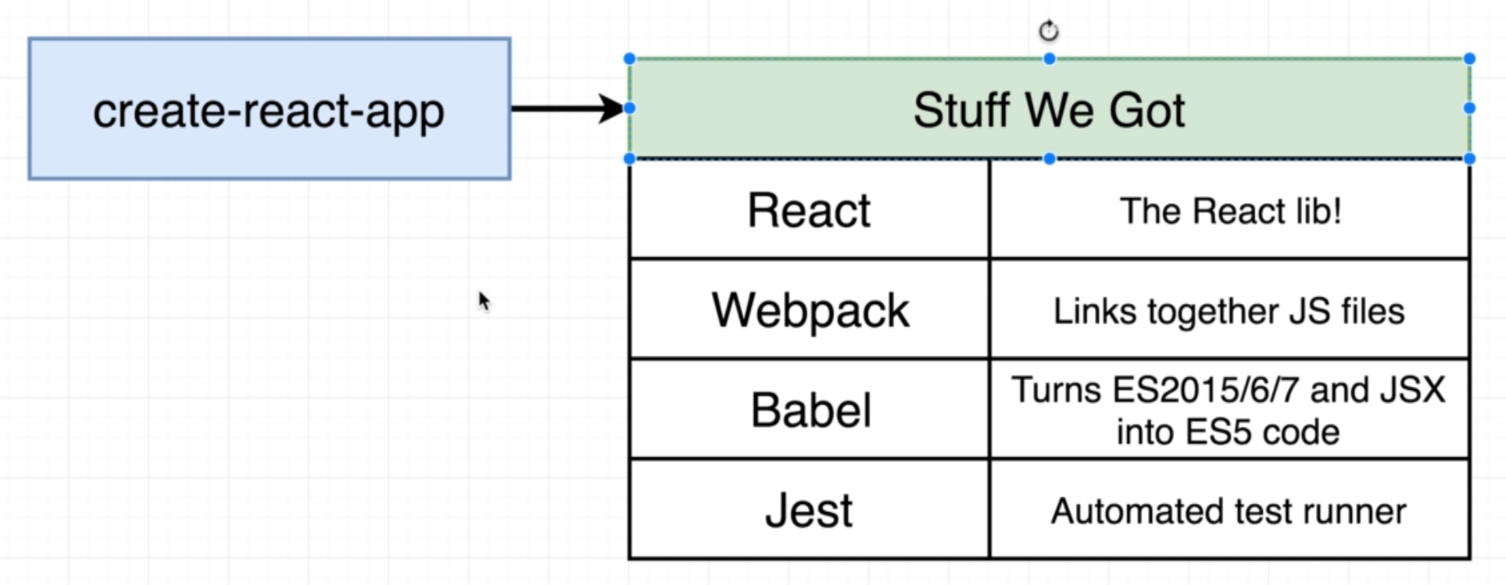

Jest: it is an automated test runner

This is what happened when we run “npm run test”

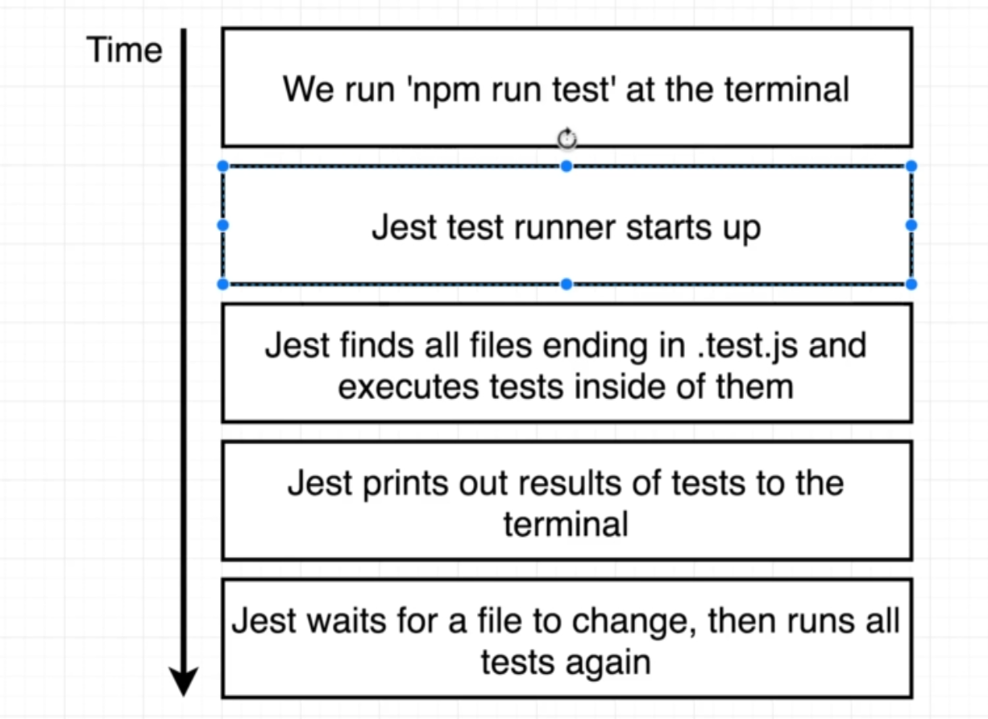

4. App Overview

This is the App that we are going to build. It adds comments to the list of comments as shown. We will also use “Redux” to know how to write test for that.

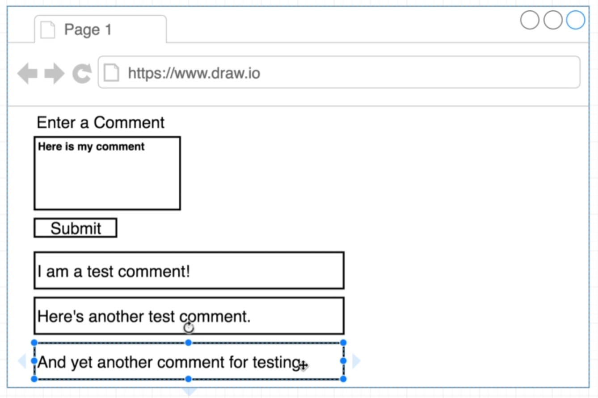

5. Installing Dependencies



6. React and Redux Design

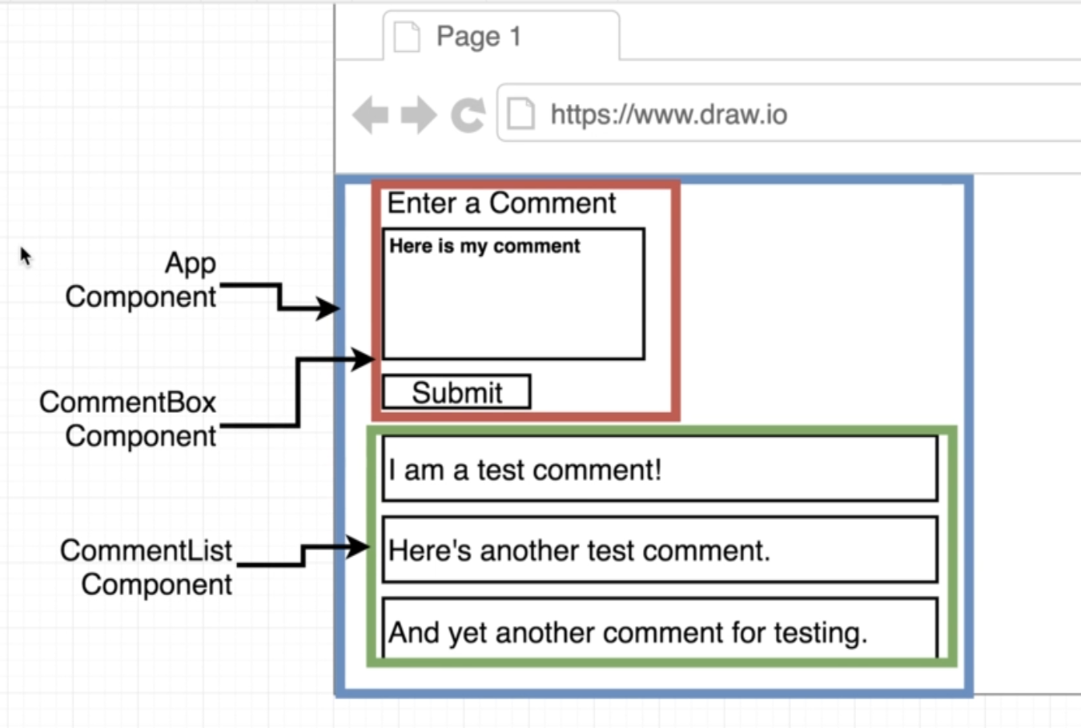

We have “state” with one reducer (comments). This is the list of array.

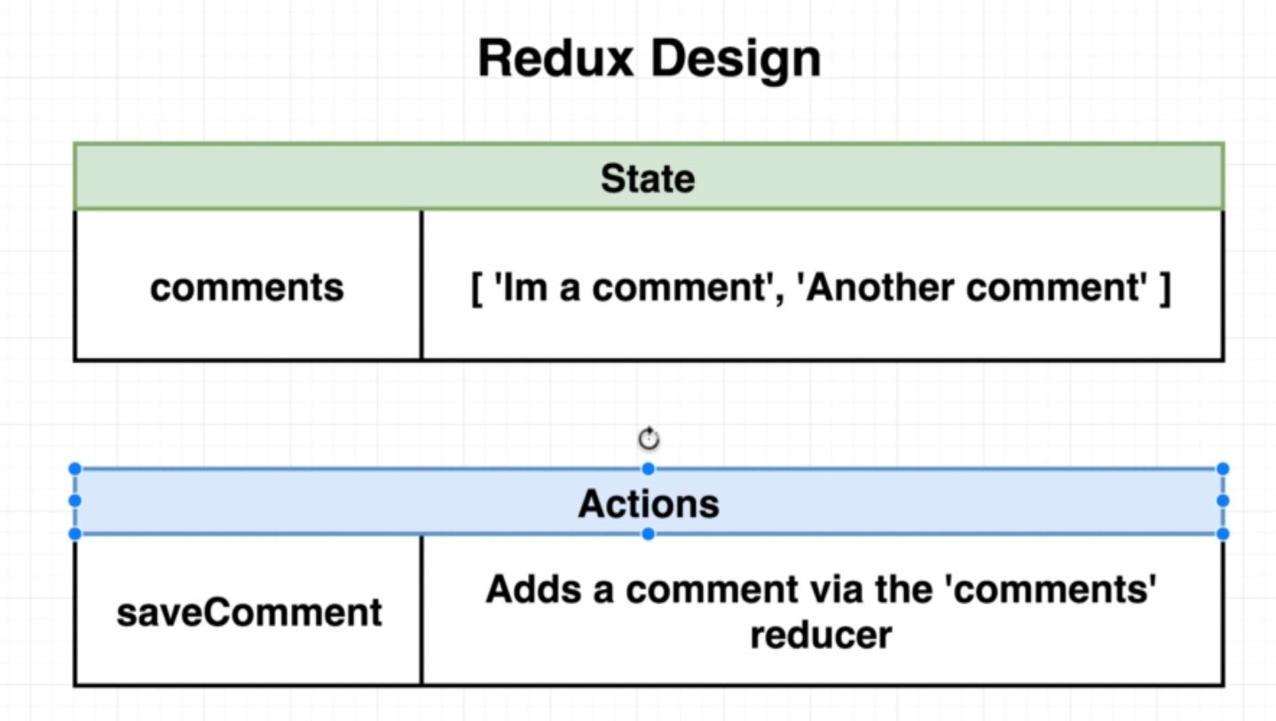

7. What Do We Test

Anytime you start writing test for your personal projects here are rules to follow.

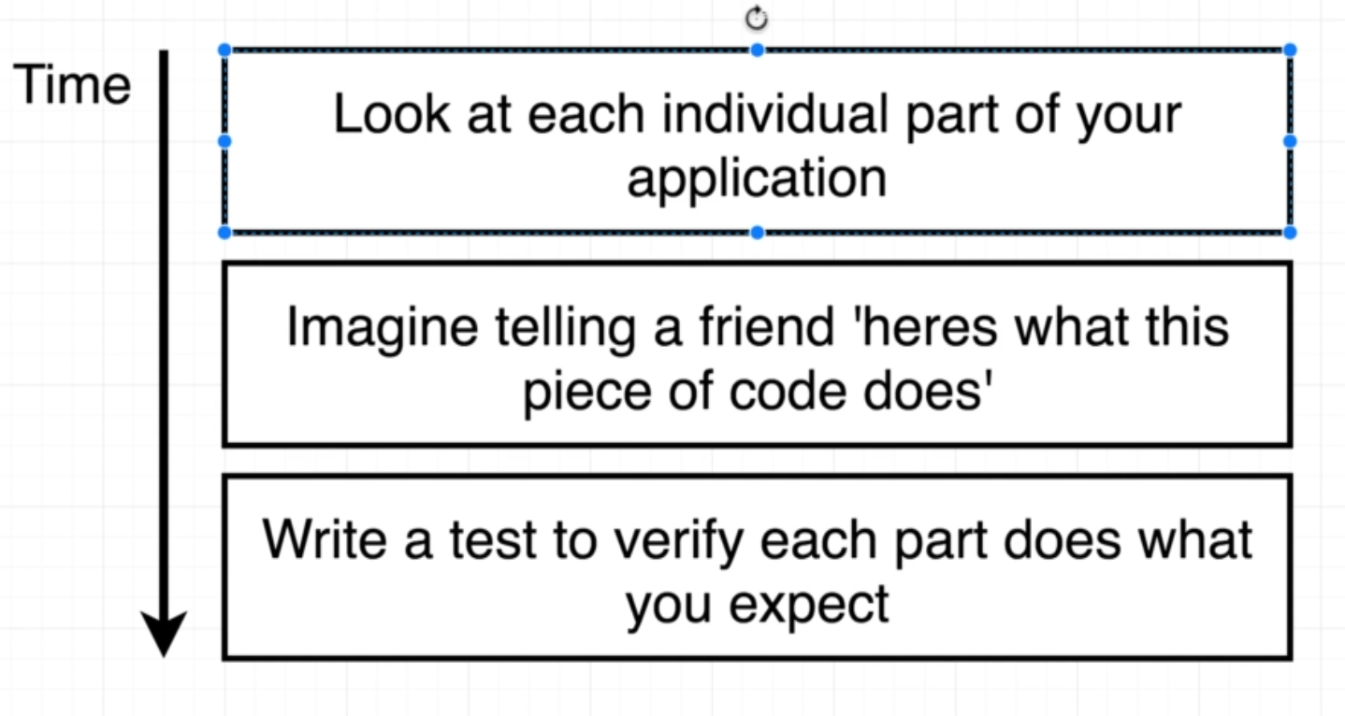

Write test for Every component, Every Reducer, and Every Action creator

Find out the purpose of each section and write test for the purpose like adding comment to list.

Example:

Write a test to make sure that comment is added successfully to the list.

These are the tests to be written for each box

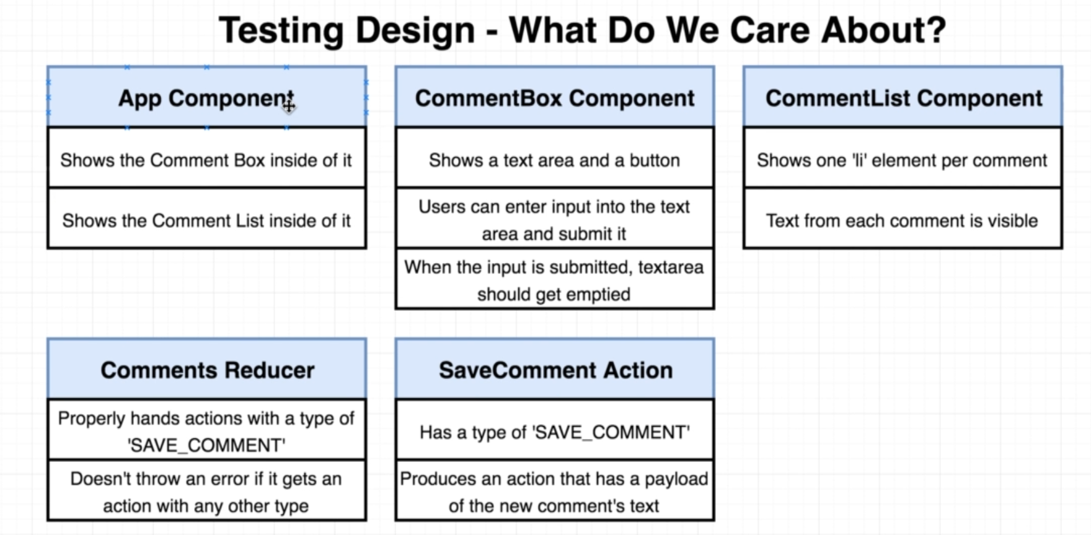

8. Starting from Scratch

9. Rendering the App

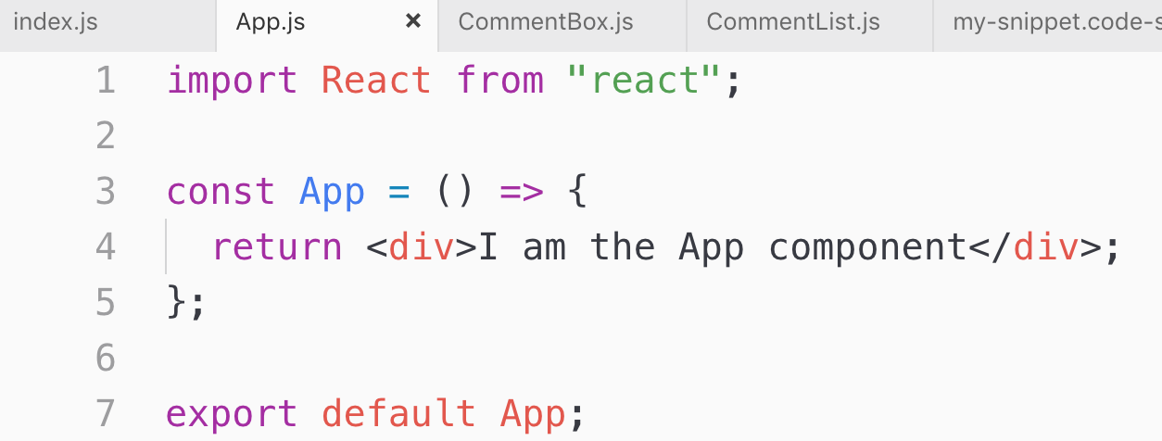

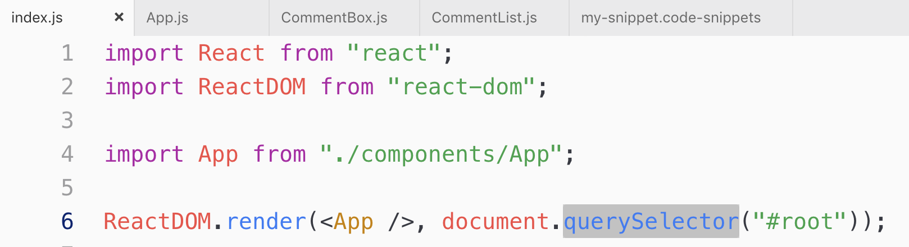

10. Showing Components in the App

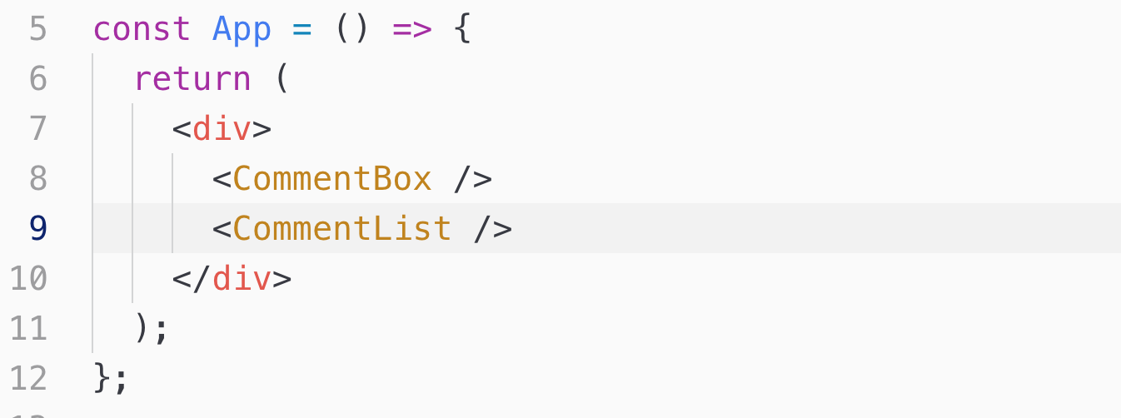

11. Valid Test File Names

We can create direct file like App.test.js or we can keep all the test files into __test__ folder

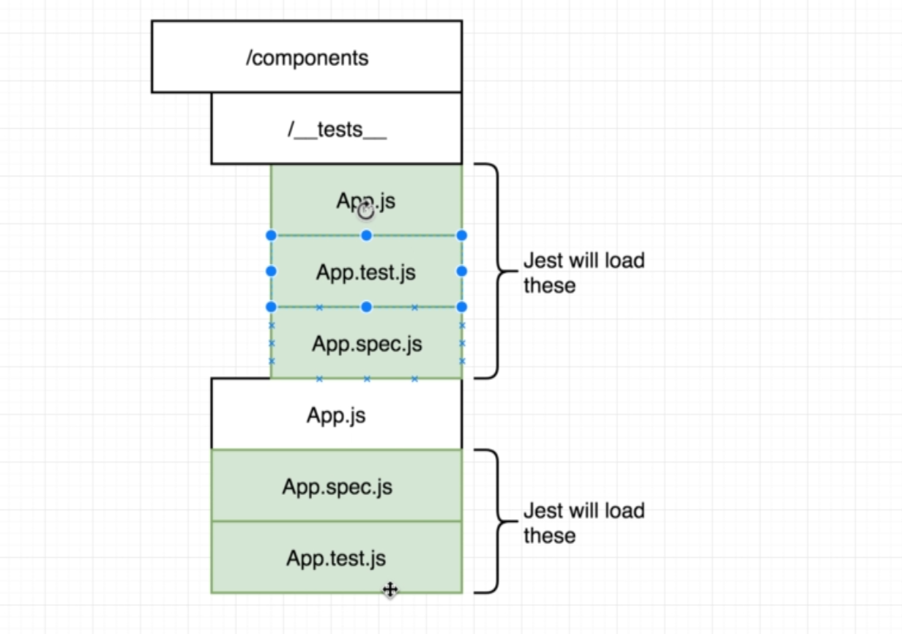

Creating __test__ folder inside components folder and create a file App.test.js

Note: we could remove test and keep it as App.js

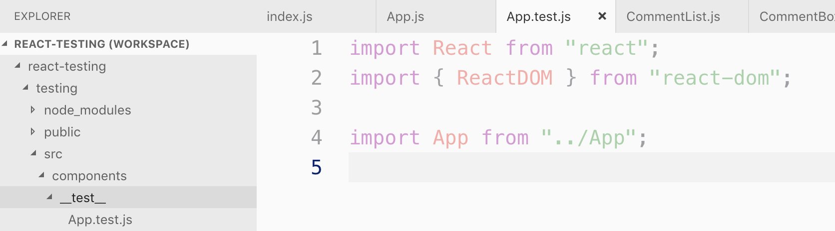

12. Test Structure

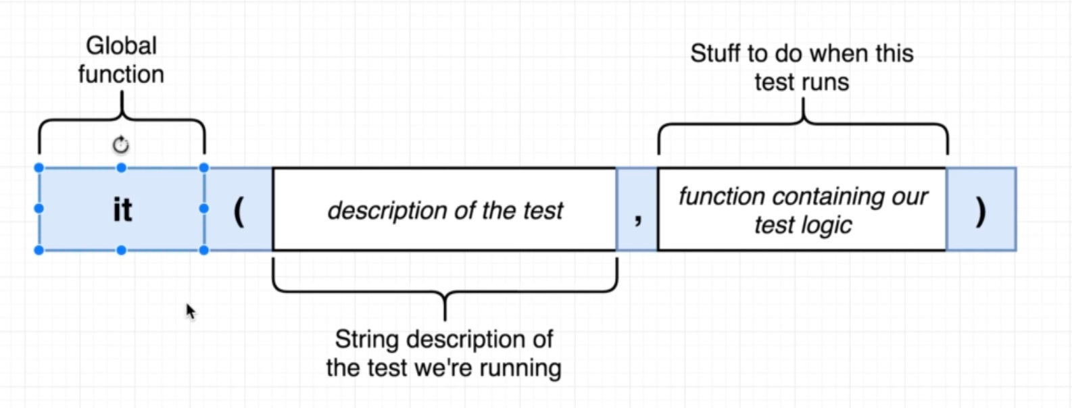

Note: it() function is a global function so we don’t have to import it

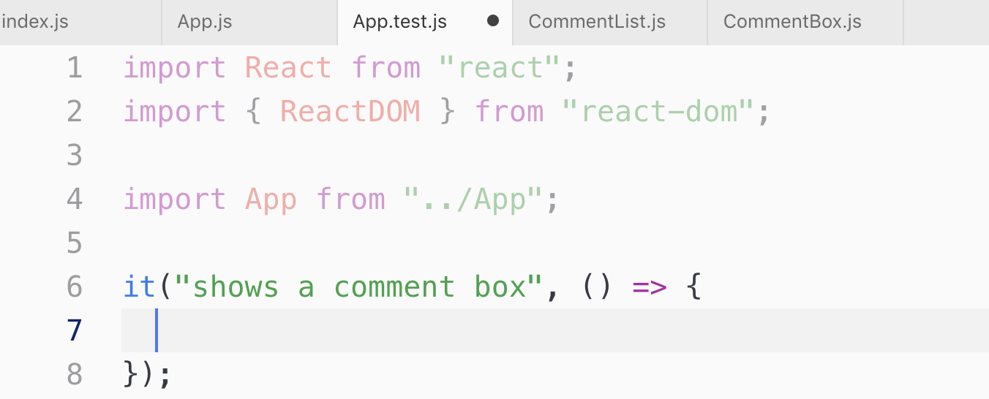

13. Tricking React with JSDOM

While generating boiler plate code using “create-react-app”, it adds a dependencies called JSDOM which is a library that has browser like environment to run in command line.

JSDOM fakes out the existence of the browser.

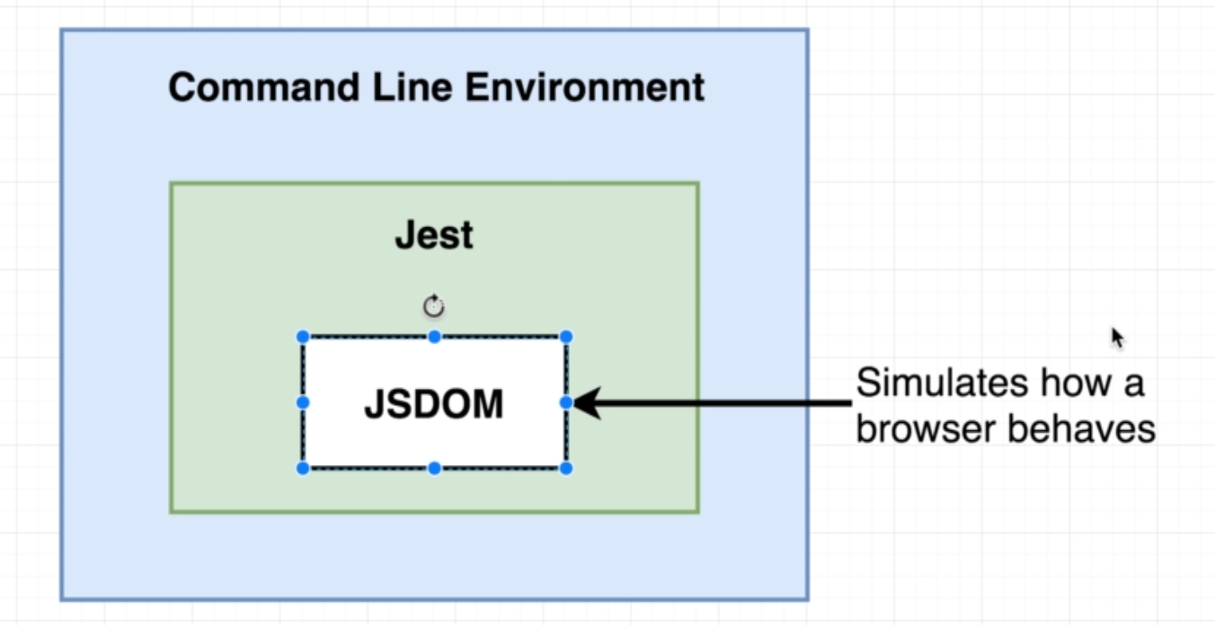

The div that we are creating above is a fake div. This div is not tied to any instance of a browser. We also clean up the component or left over object to make things run smoothly as we did in the below code.

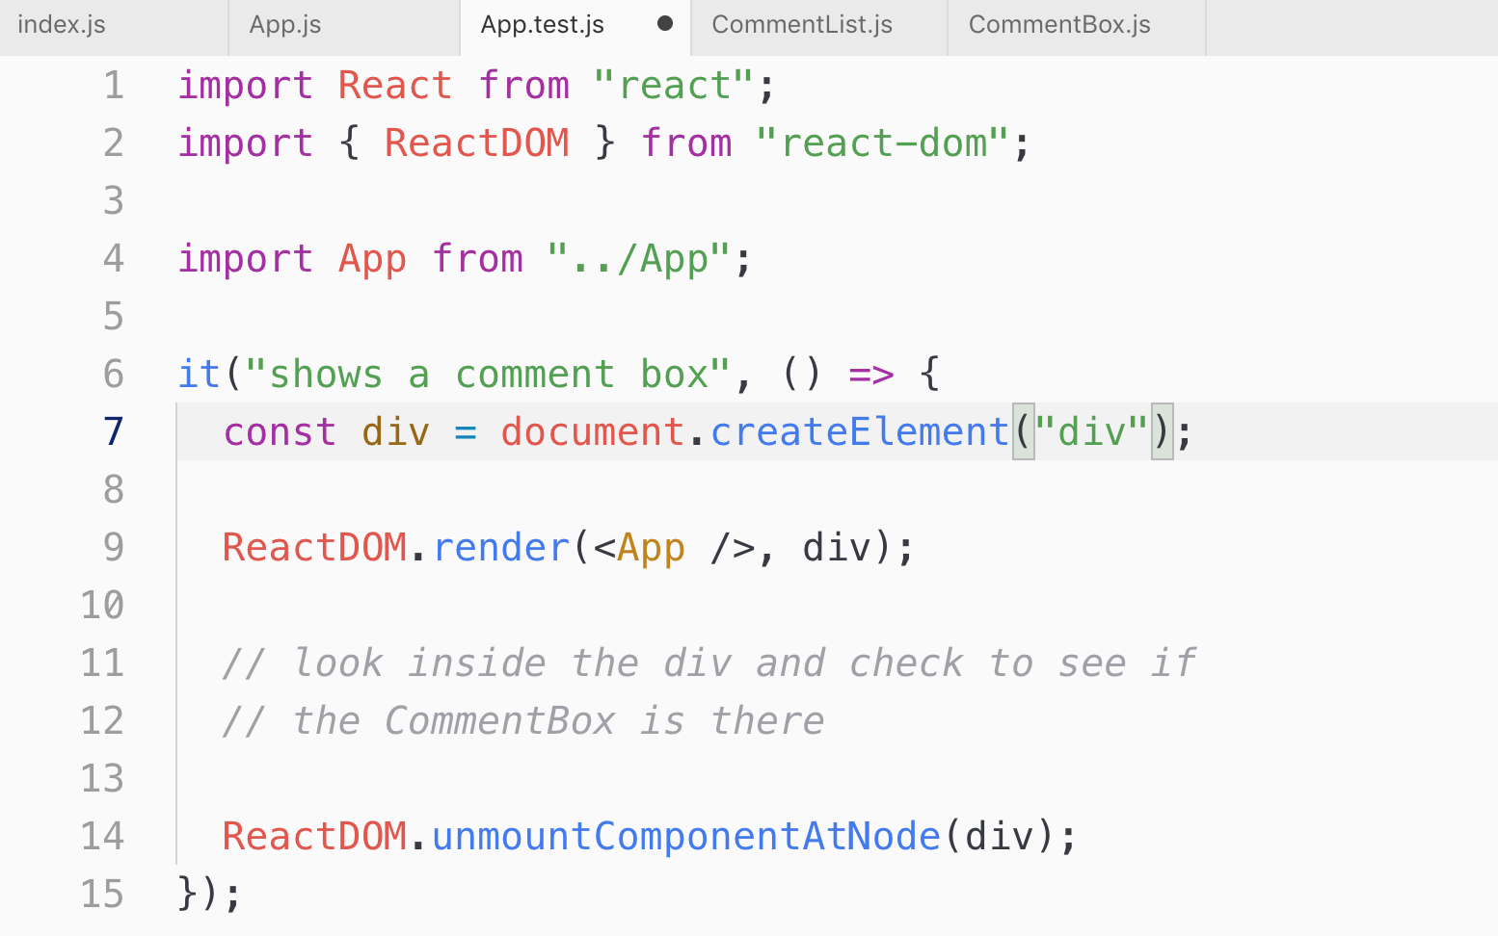

14. Verifying Component Existence

You can verify what’s inside the element by console.log() like this.

console.log(div.innerHTML)

<div><div>Comment Box</div><div>Component List</div></div>

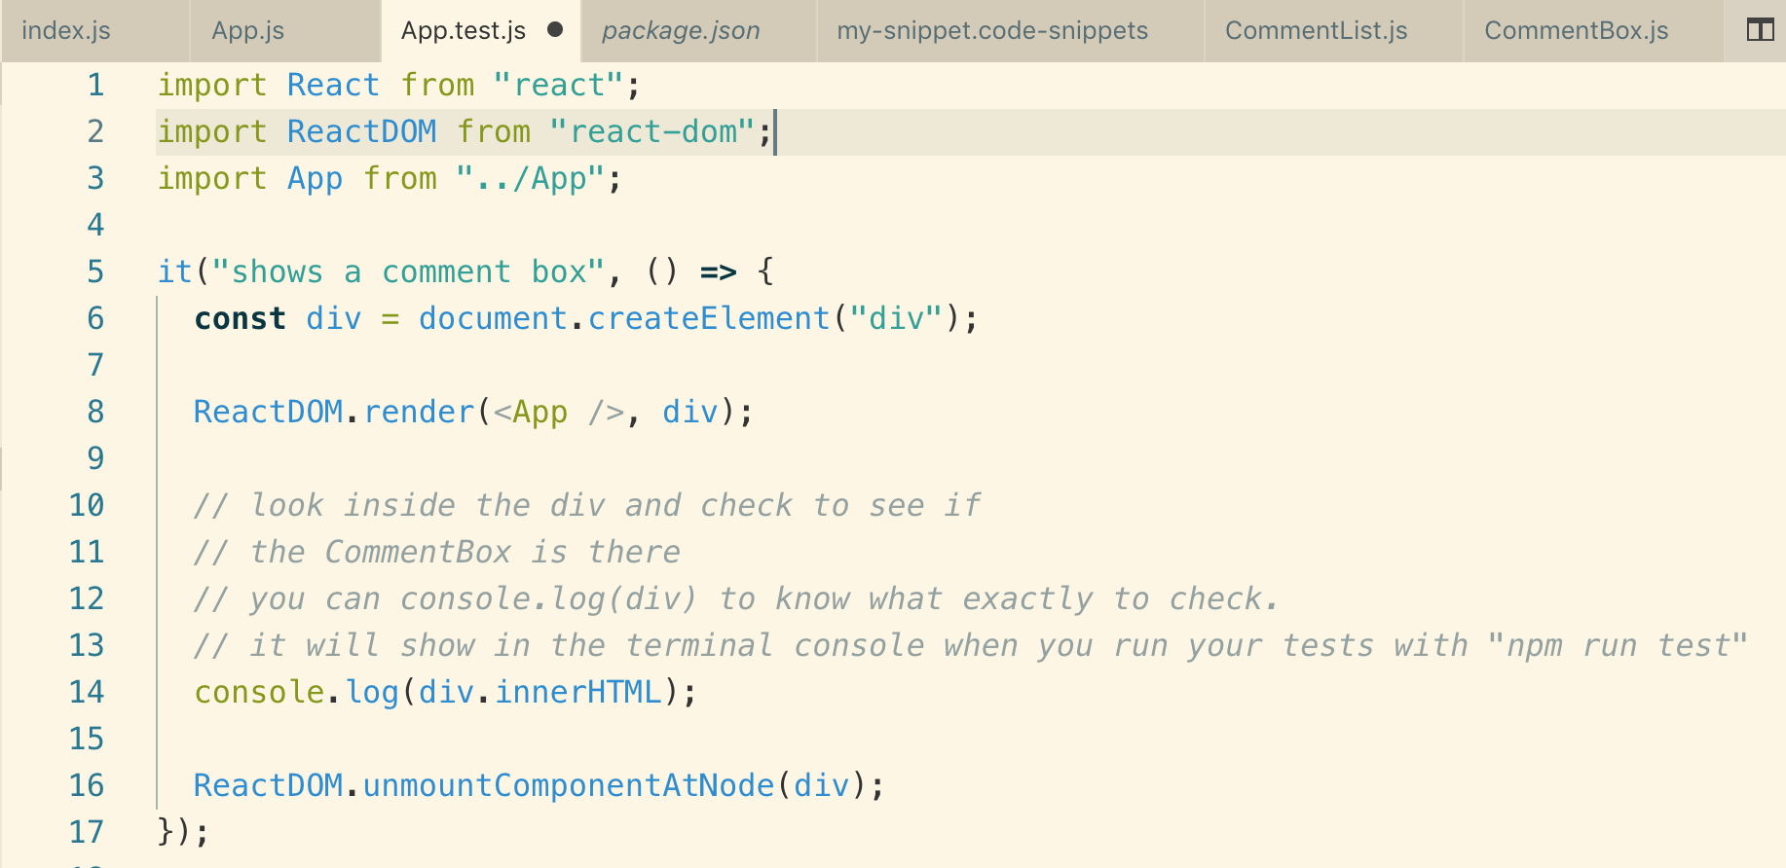

15. Test Expectations

Value is not required in some cases like

expect(div.innerHTML).toBeTruthy(); so here the matcher does not require an argument.

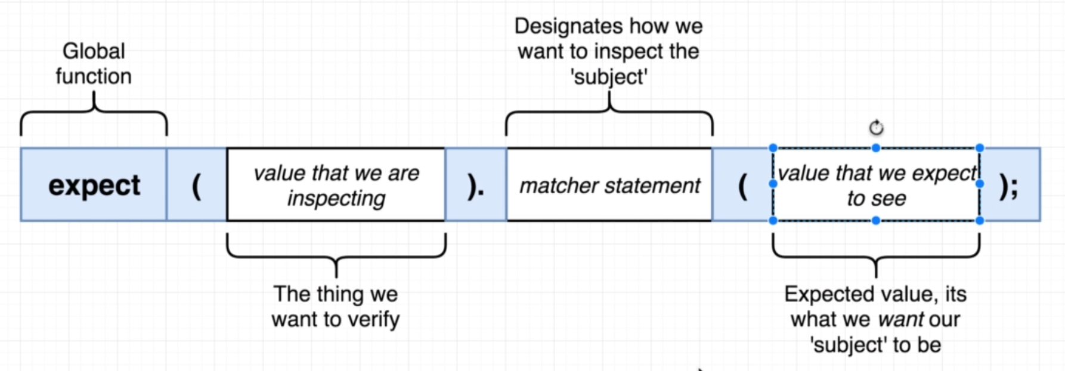

16. Limiting Test Knowledge.mp4

We should not test working of inner component if possible if someone changes the content of inner component, your test will fail.

As shown in below diagram,

APP => CommentList

=> CommentBox

So not to test the inner workings of a child component just test that the inner component does exits!

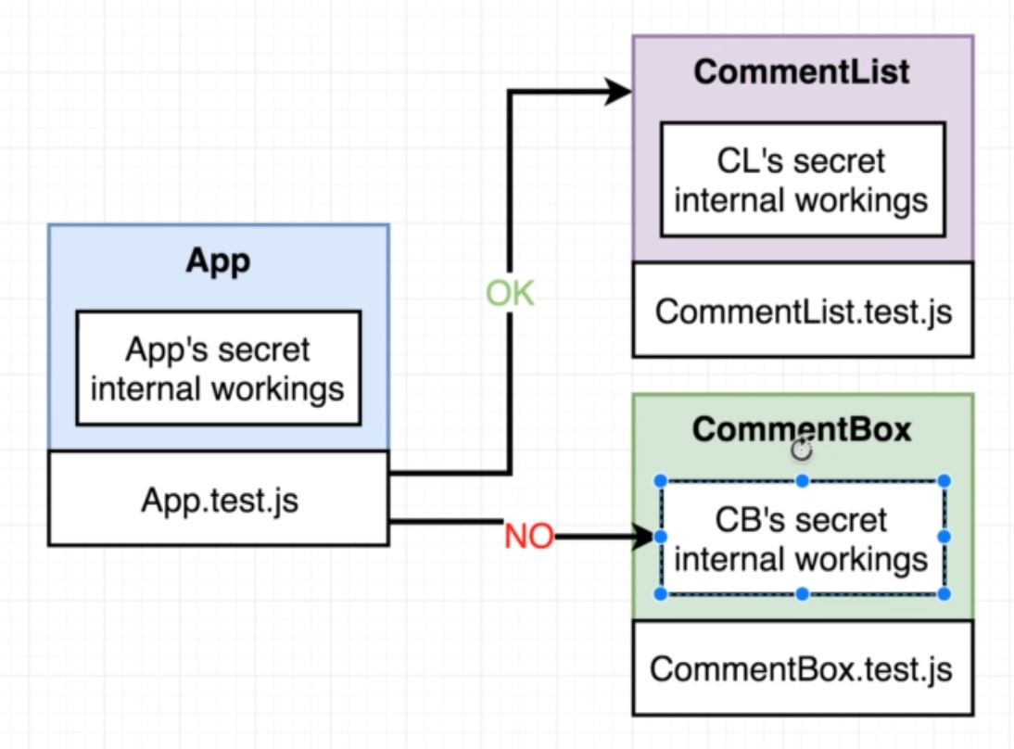

So we will just test that the App contains “CommentBox” so if the content of the “CommentBox” changes, your test will not fail.

17. Enzyme Setup

*// The is the preffered way*

expect(div).toHaveAnInstanceOf("CommentBox");

We want to check like shown above in the code, but there is no function available like this “toHaveAnIntanceOf”, but there is a library which can do similar like this called **“Enzyme”**

**Enzyme** is created by AirBNB.

These 2 packages that we need to install for enzyme



Note : 16 is the version of your React, you can check in the package.json file and then put it here and setup of enzyme is also different according to the version.

Setup Enzyme

Mind the name of the file. it is really important

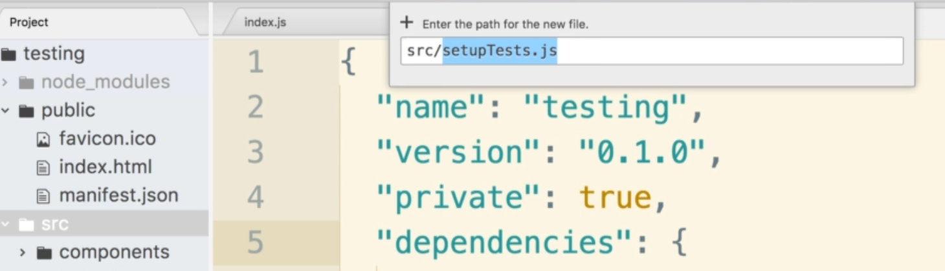

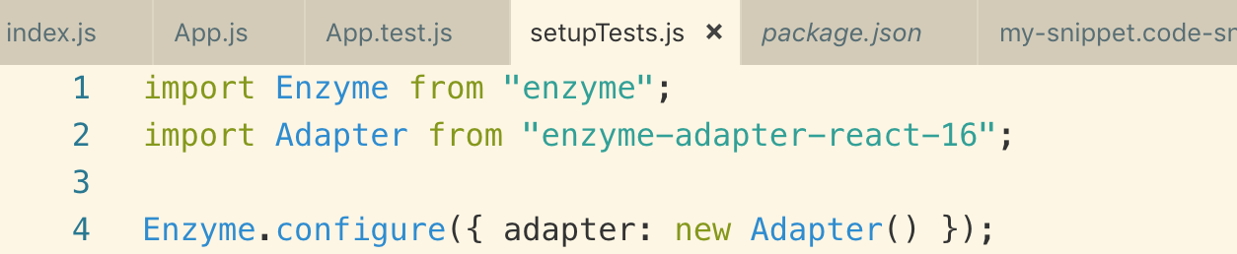

Note: anytime Jest starts up our project it is going to look for a file with the name of setupTests.js inside the src directory and if JEST finds that file it will automatically execute it before any other code inside of our project is loaded.

19. Expectations for Component Instances

Shallow : is a function that we use to render out an instance of our App component and none of its children

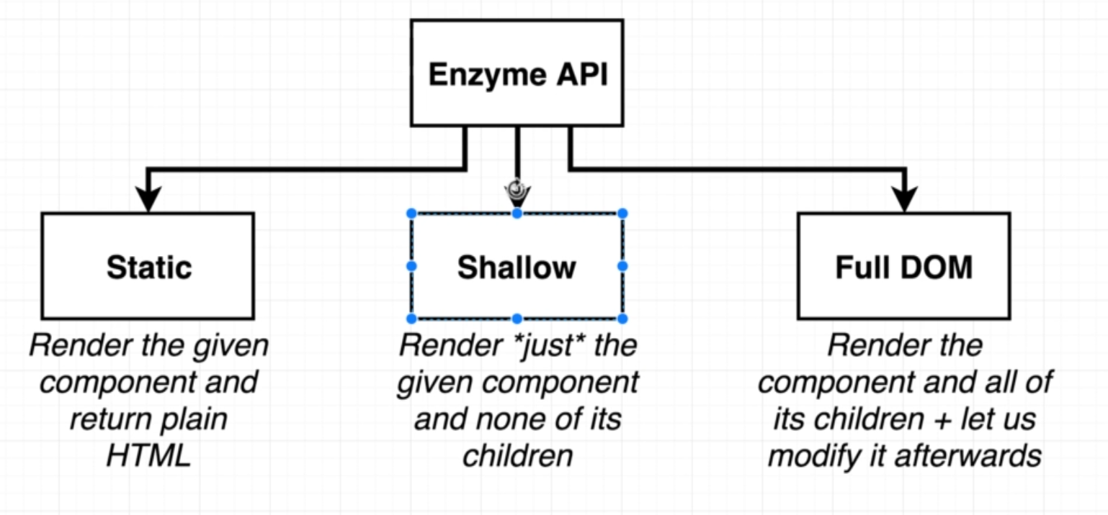

Note: If the component that we render if it has DOM elements inside of it like a div or a header tag, or text box input those will be rendered. It is specifically react child component that will not be rendered.

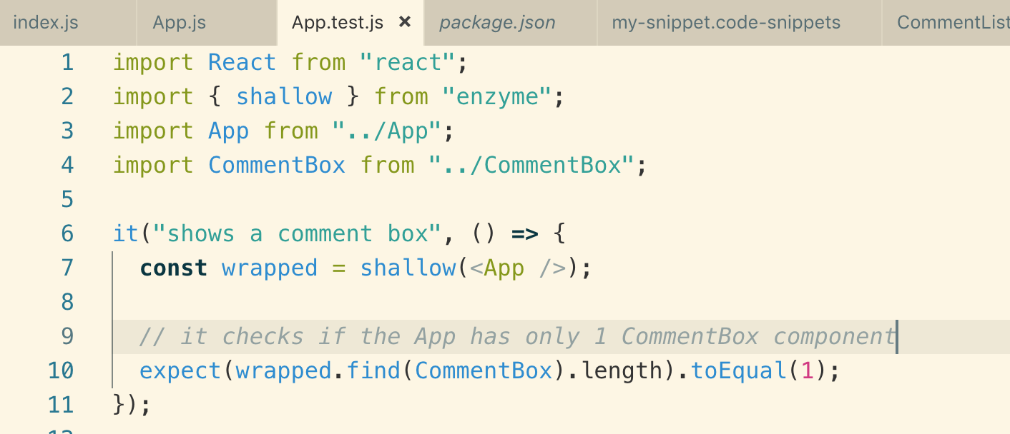

Note: try to make your test break so you have an idea how to fix it

20. Exercise Time!

make

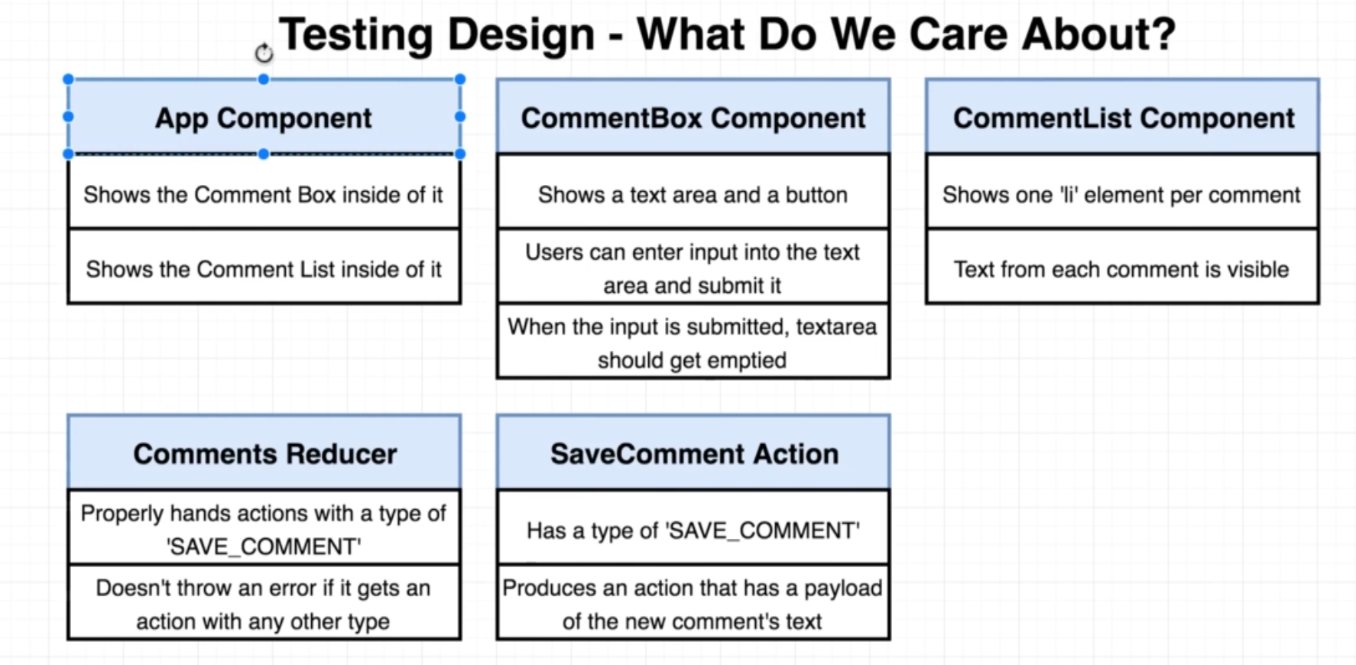

21. Expecting the Comment List

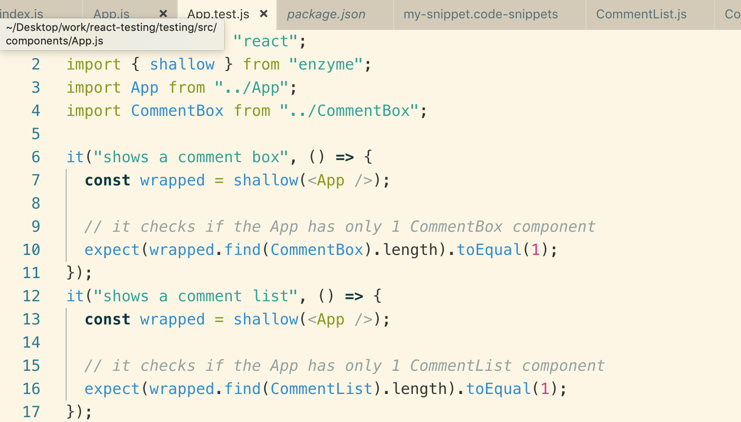

22. Absolute Path Imports

Anytime we are in a webpack or node project, we always have to write relative paths to the files that we are trying to import.

Absolute path just makes our life easier, not important to have it for test or react. Just personal preference

We will create a new file .env inside of our root directory

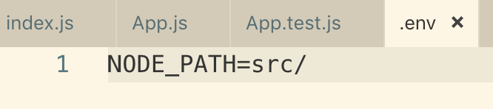

We need to restart our server. Now our path starts from **/src**

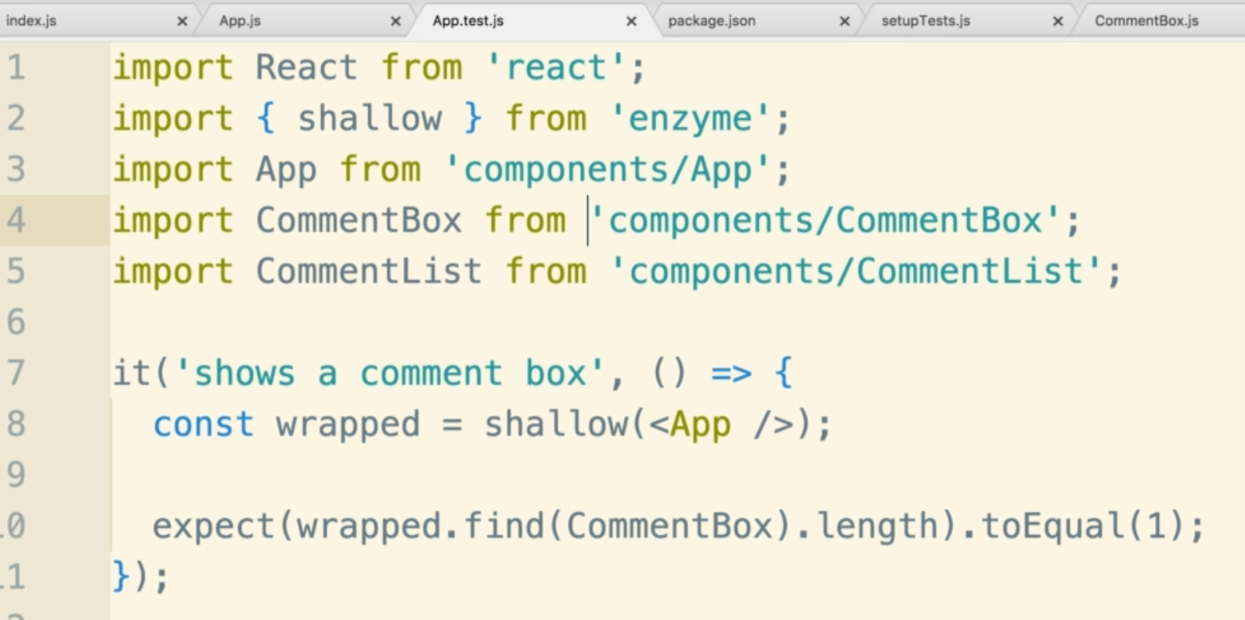

23. Code Reuse with BeforeEach

There is code re-factor that we can do about 2 tests we wrote above

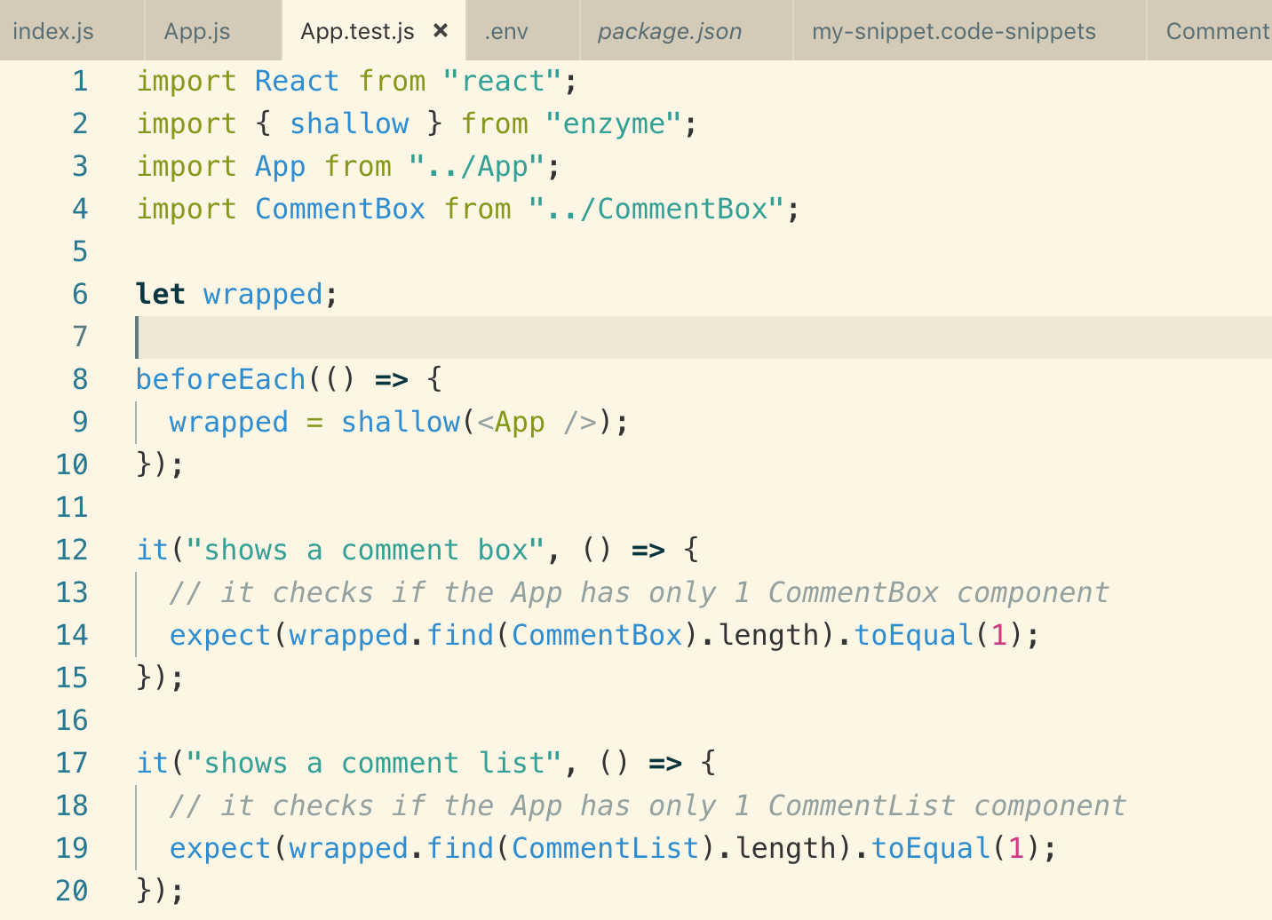

Refactor code is below

Anytime you find something similar code between multiple test, you can run Jest’s helper function called beforeEach

Note: beforeEach runs before each test

24. Comment Box Component

Our App structure

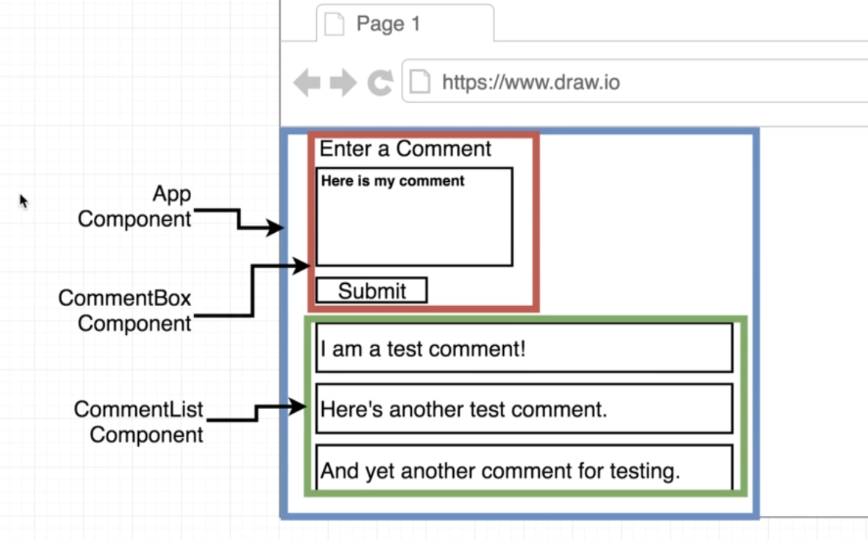

Turning functional component into class component

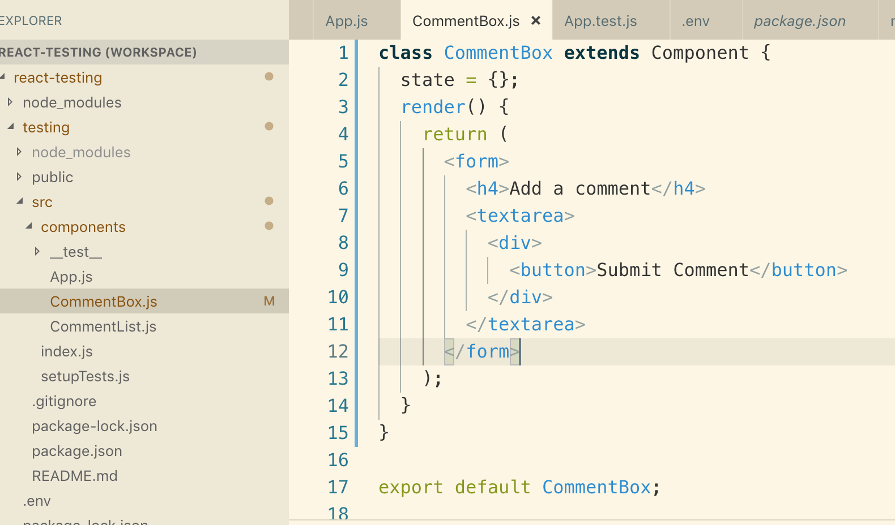

25. TextArea Implementation

Making textarea as a controlled element and clearing the text when clicking on submit button.

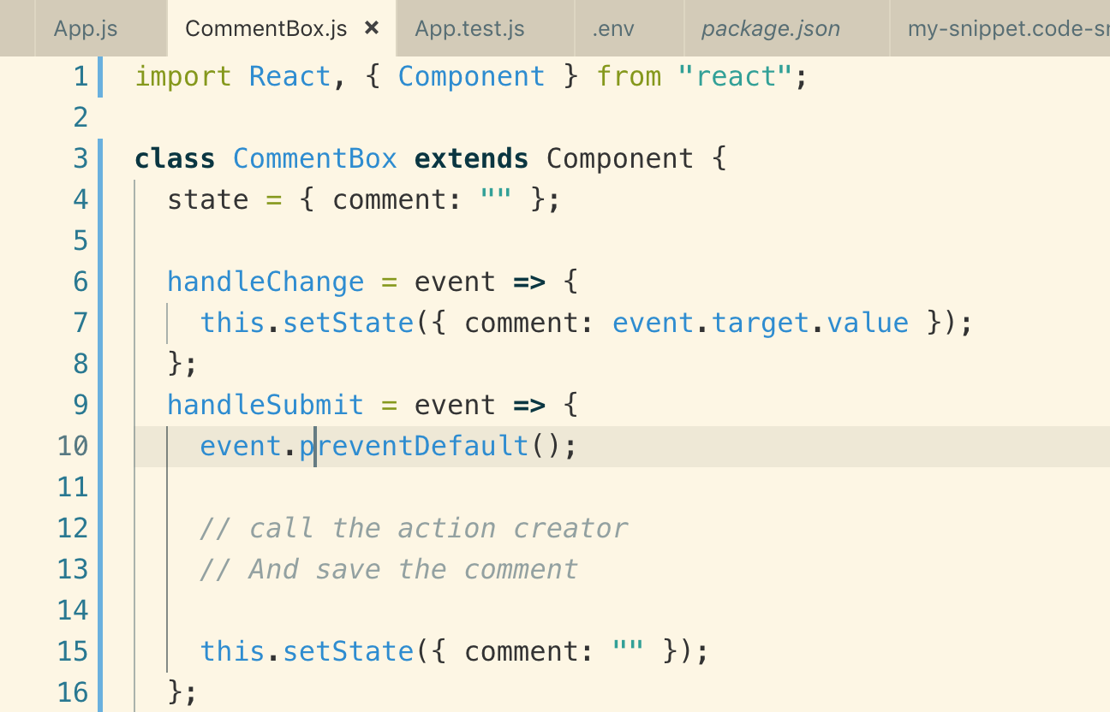

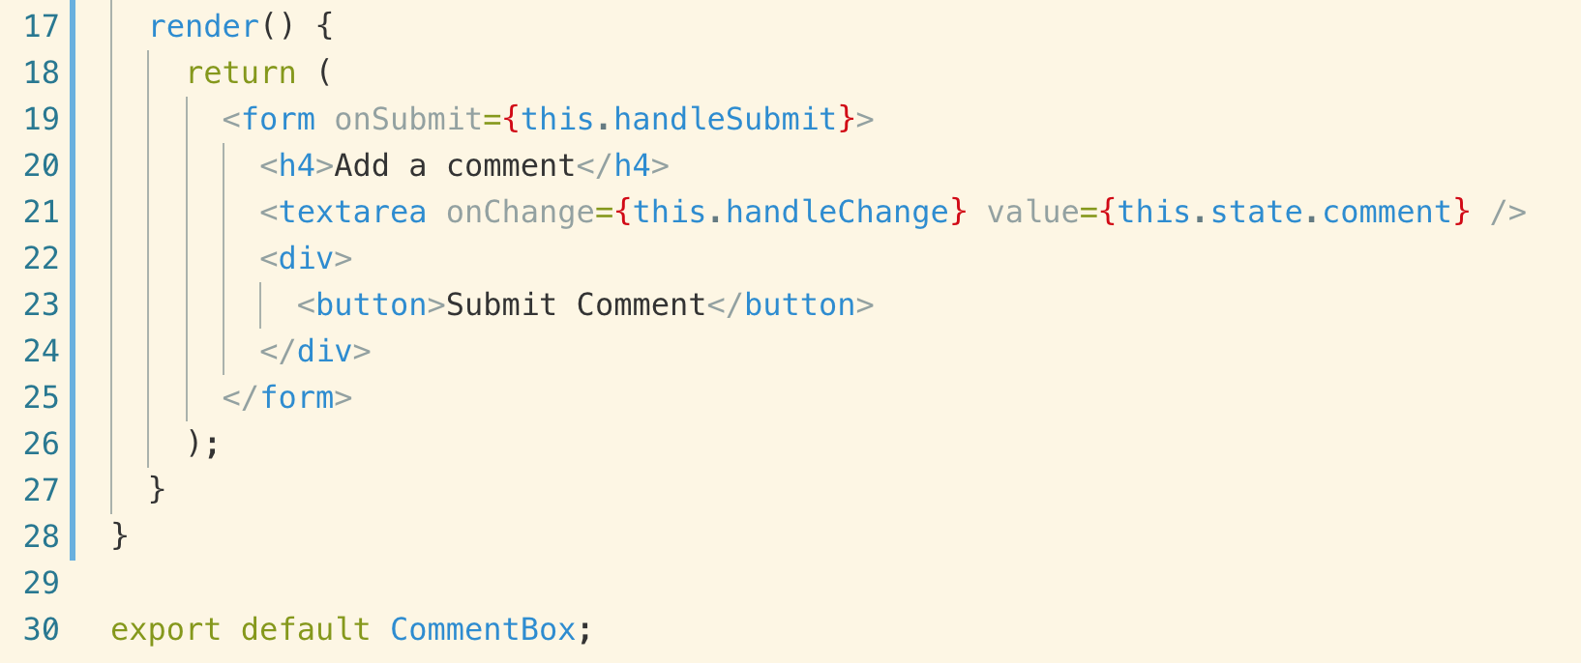

26. CommentBox Test File

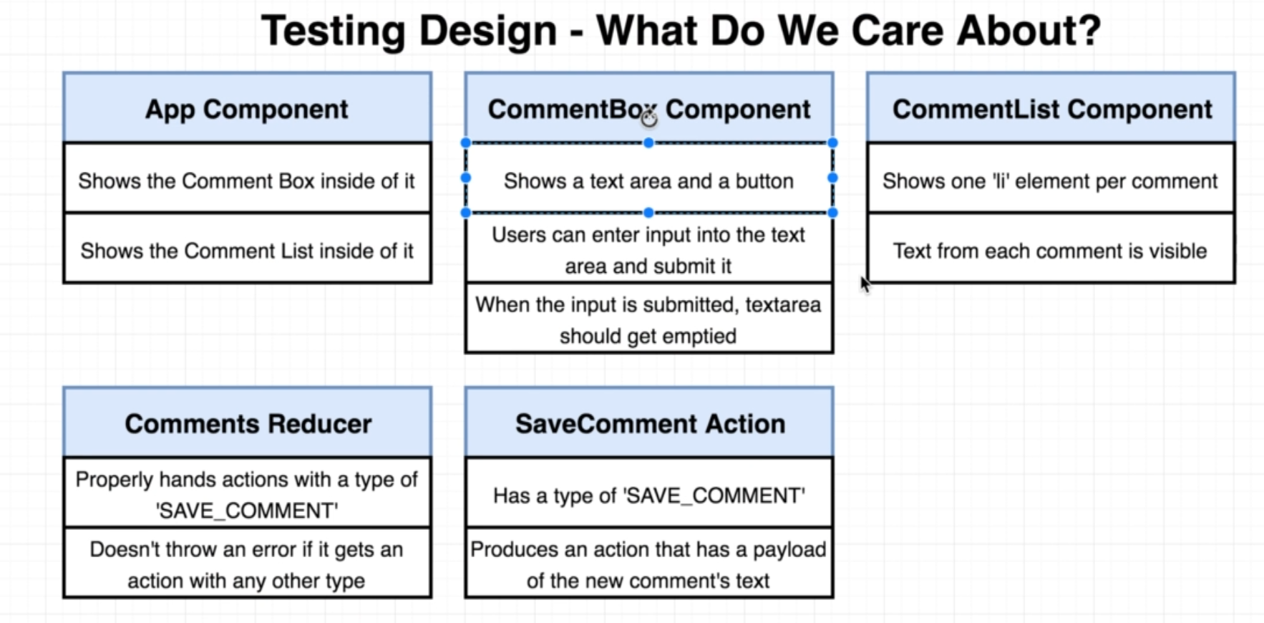

These are the three different methods of Enzyme to test a component and let’s decide which one is best suited for CommentBox component

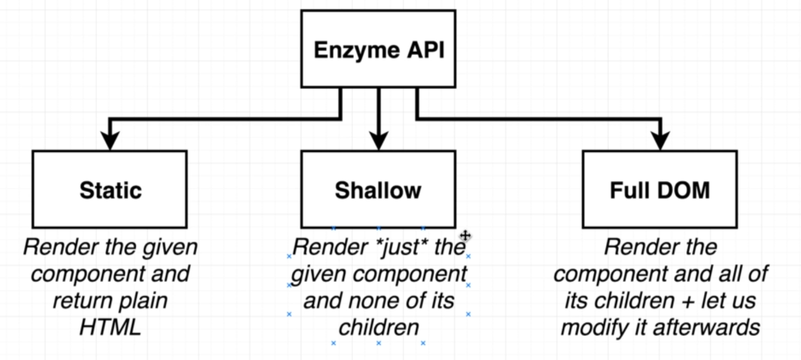

**Note:** CommentBox **doesn’t have any other component as its children so we** will not use Shallow

**We will use** Full DOM **method instead**

**Creating a new file in** component/__test__/**CommentBox.test.js**

27. Asserting Element Existence

25. TextArea Implementation

